I’m going to join
The Big Friendly Read
at the library
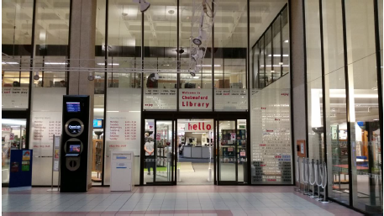

About the The Big Friendly Read

The Big Friendly Read is the name of the Summer Reading Challenge.  It is an event that happens every summer in the library. | 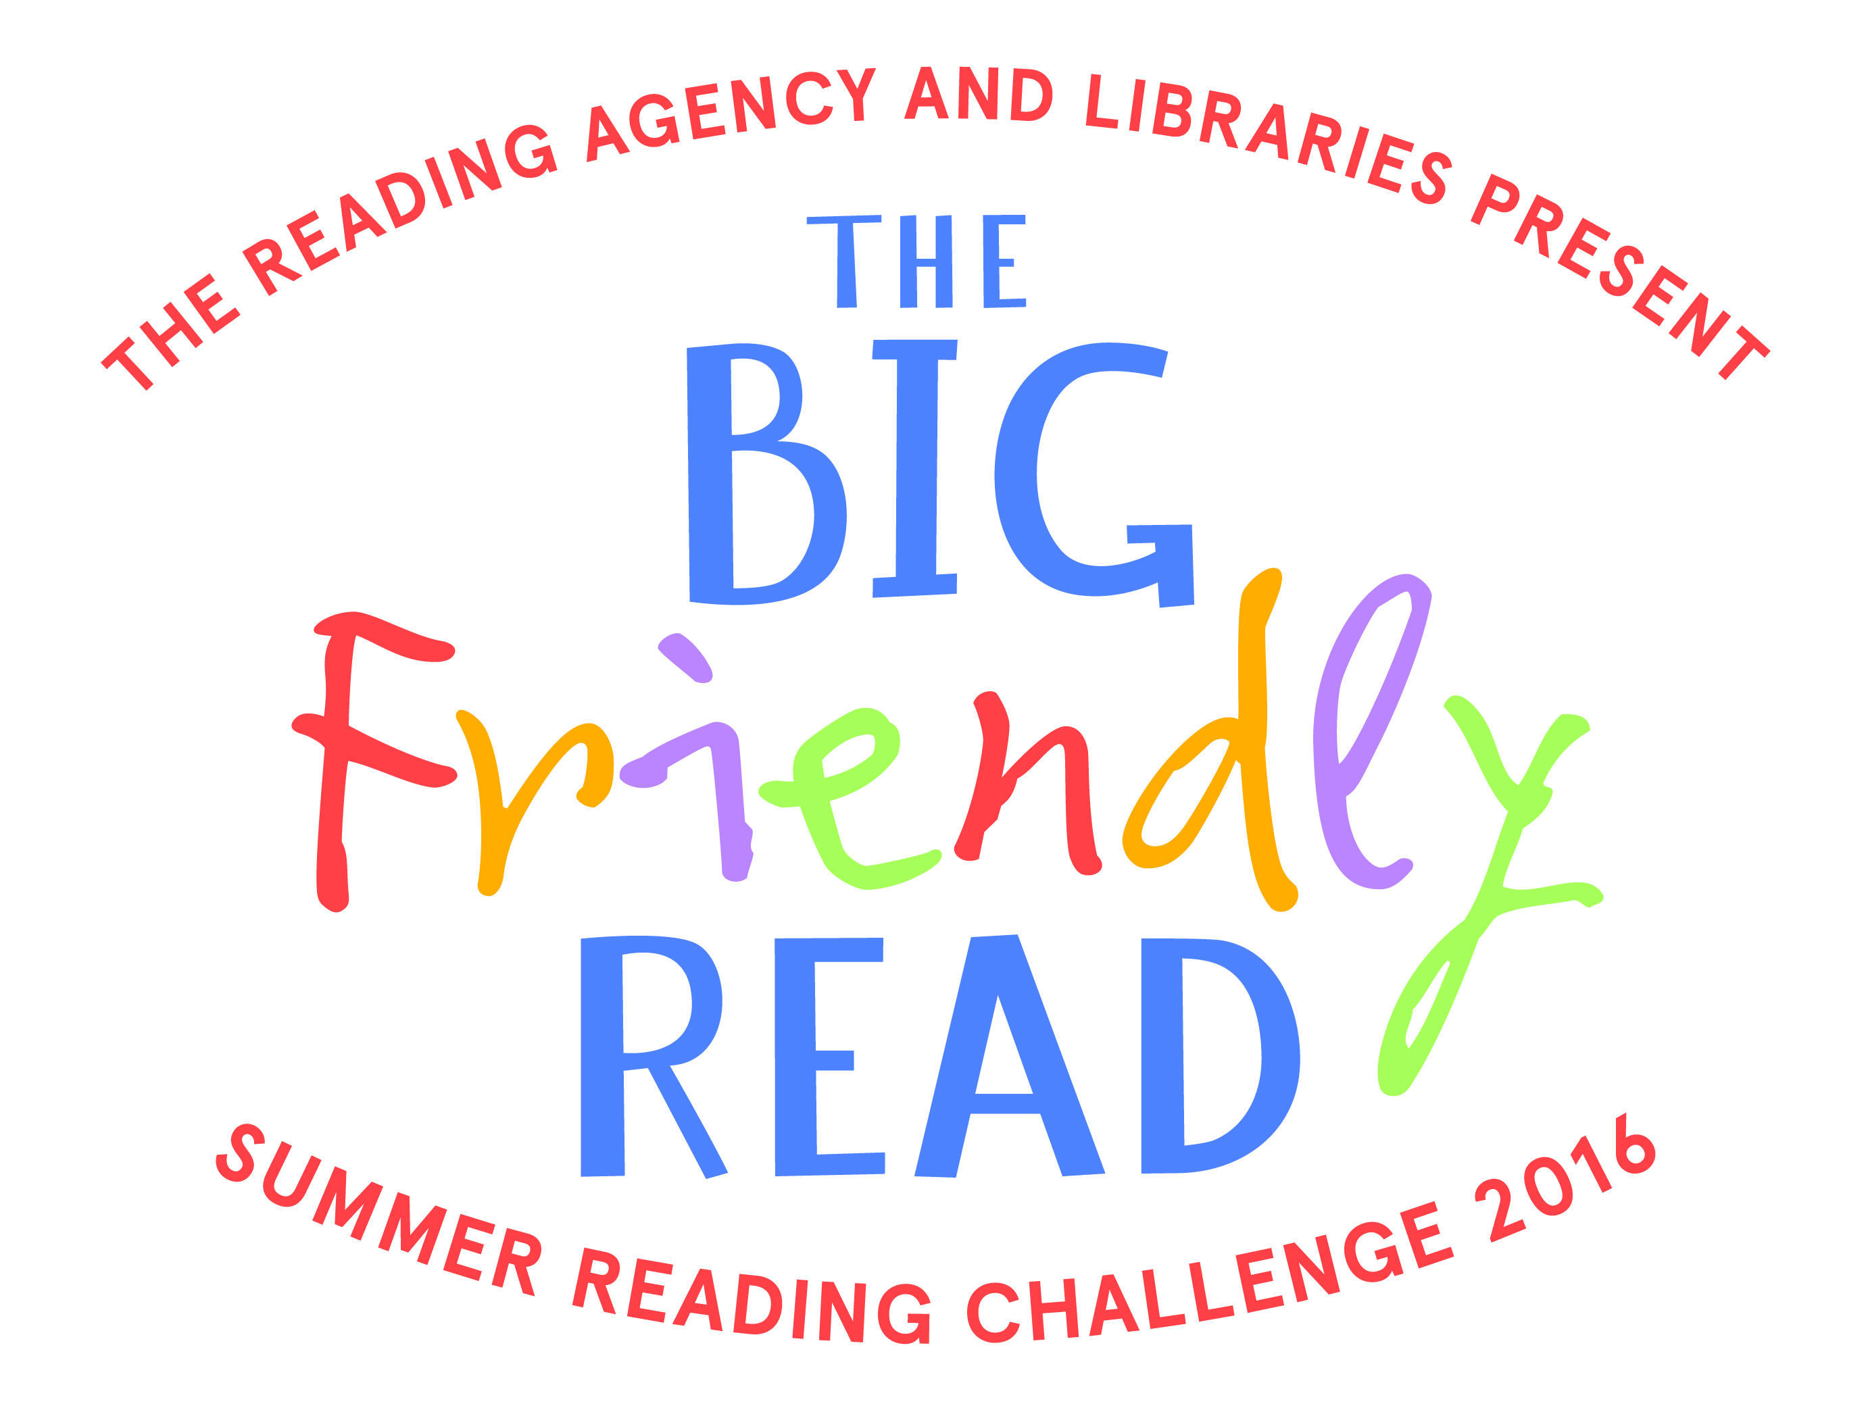
How I join The Big Friendly Read

To join The Big Friendly Read I will need to go into a library. |  | 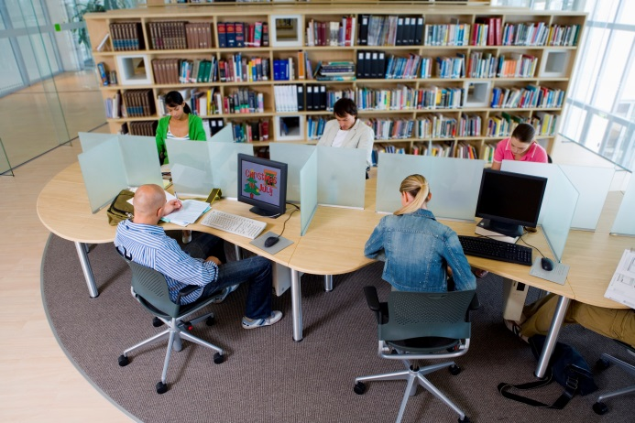
I will tell the library staff that I would like to join The Big Friendly Read. |  | 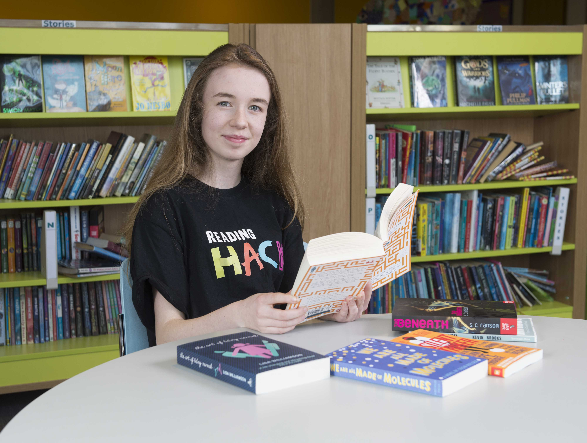

I will show the library staff my Library Card.

If I don’t have a Library Card they will give me one.
I will need to write my name, age and school on a form.  The library staff will help me if I need it. | 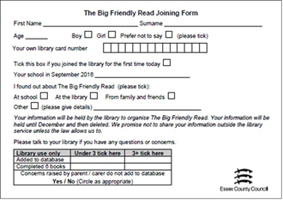
The library staff will give me some information about the Big Friendly Read.  They will give me a folder. | 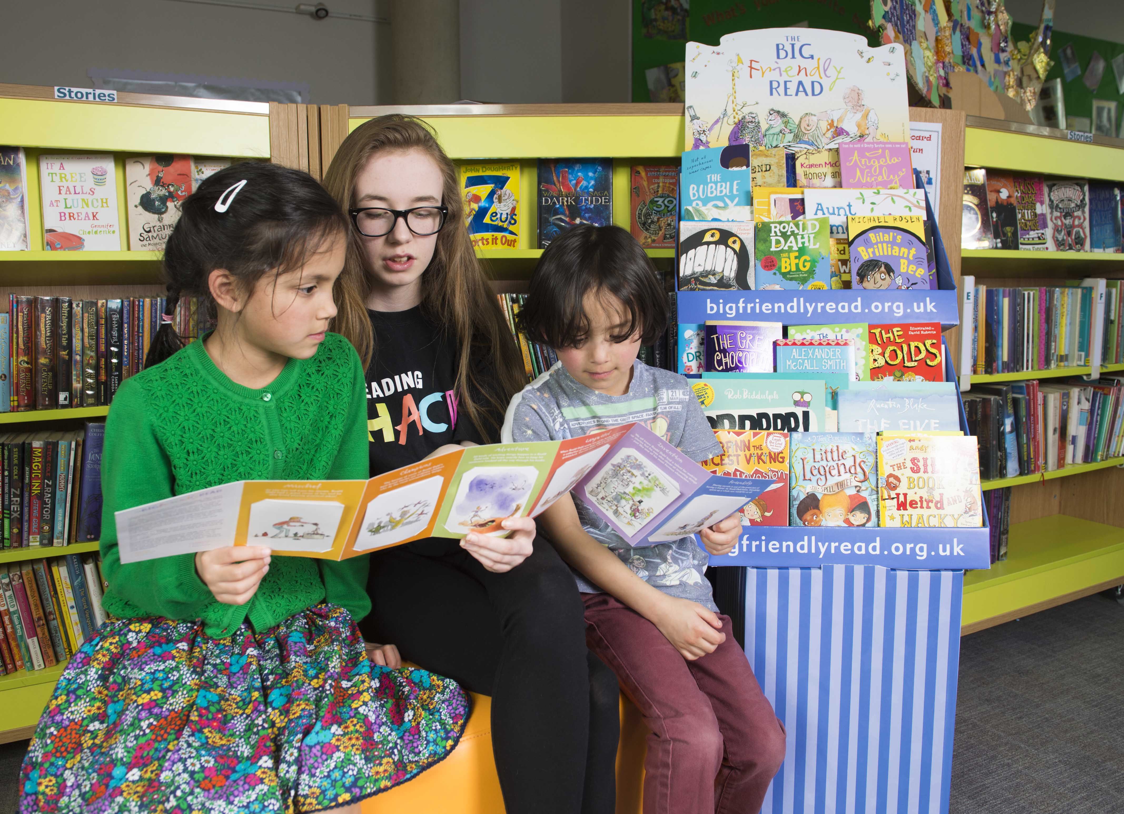

What I will do for The Big Friendly Read

To complete The Big Friendly Read I must read 6 books over the summer holiday.  The library staff can help me choose some books. | 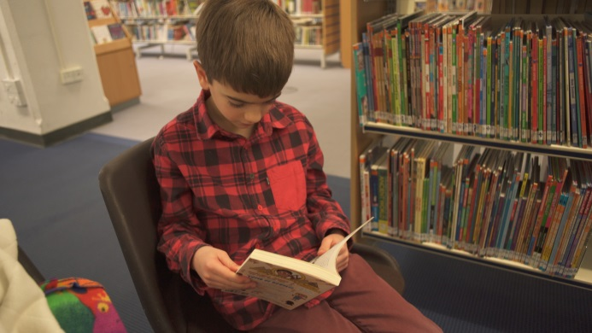
I do not have to read a book on my own. I can share a book with someone if I like.  I can listen to an audio book if I do not want to read. | 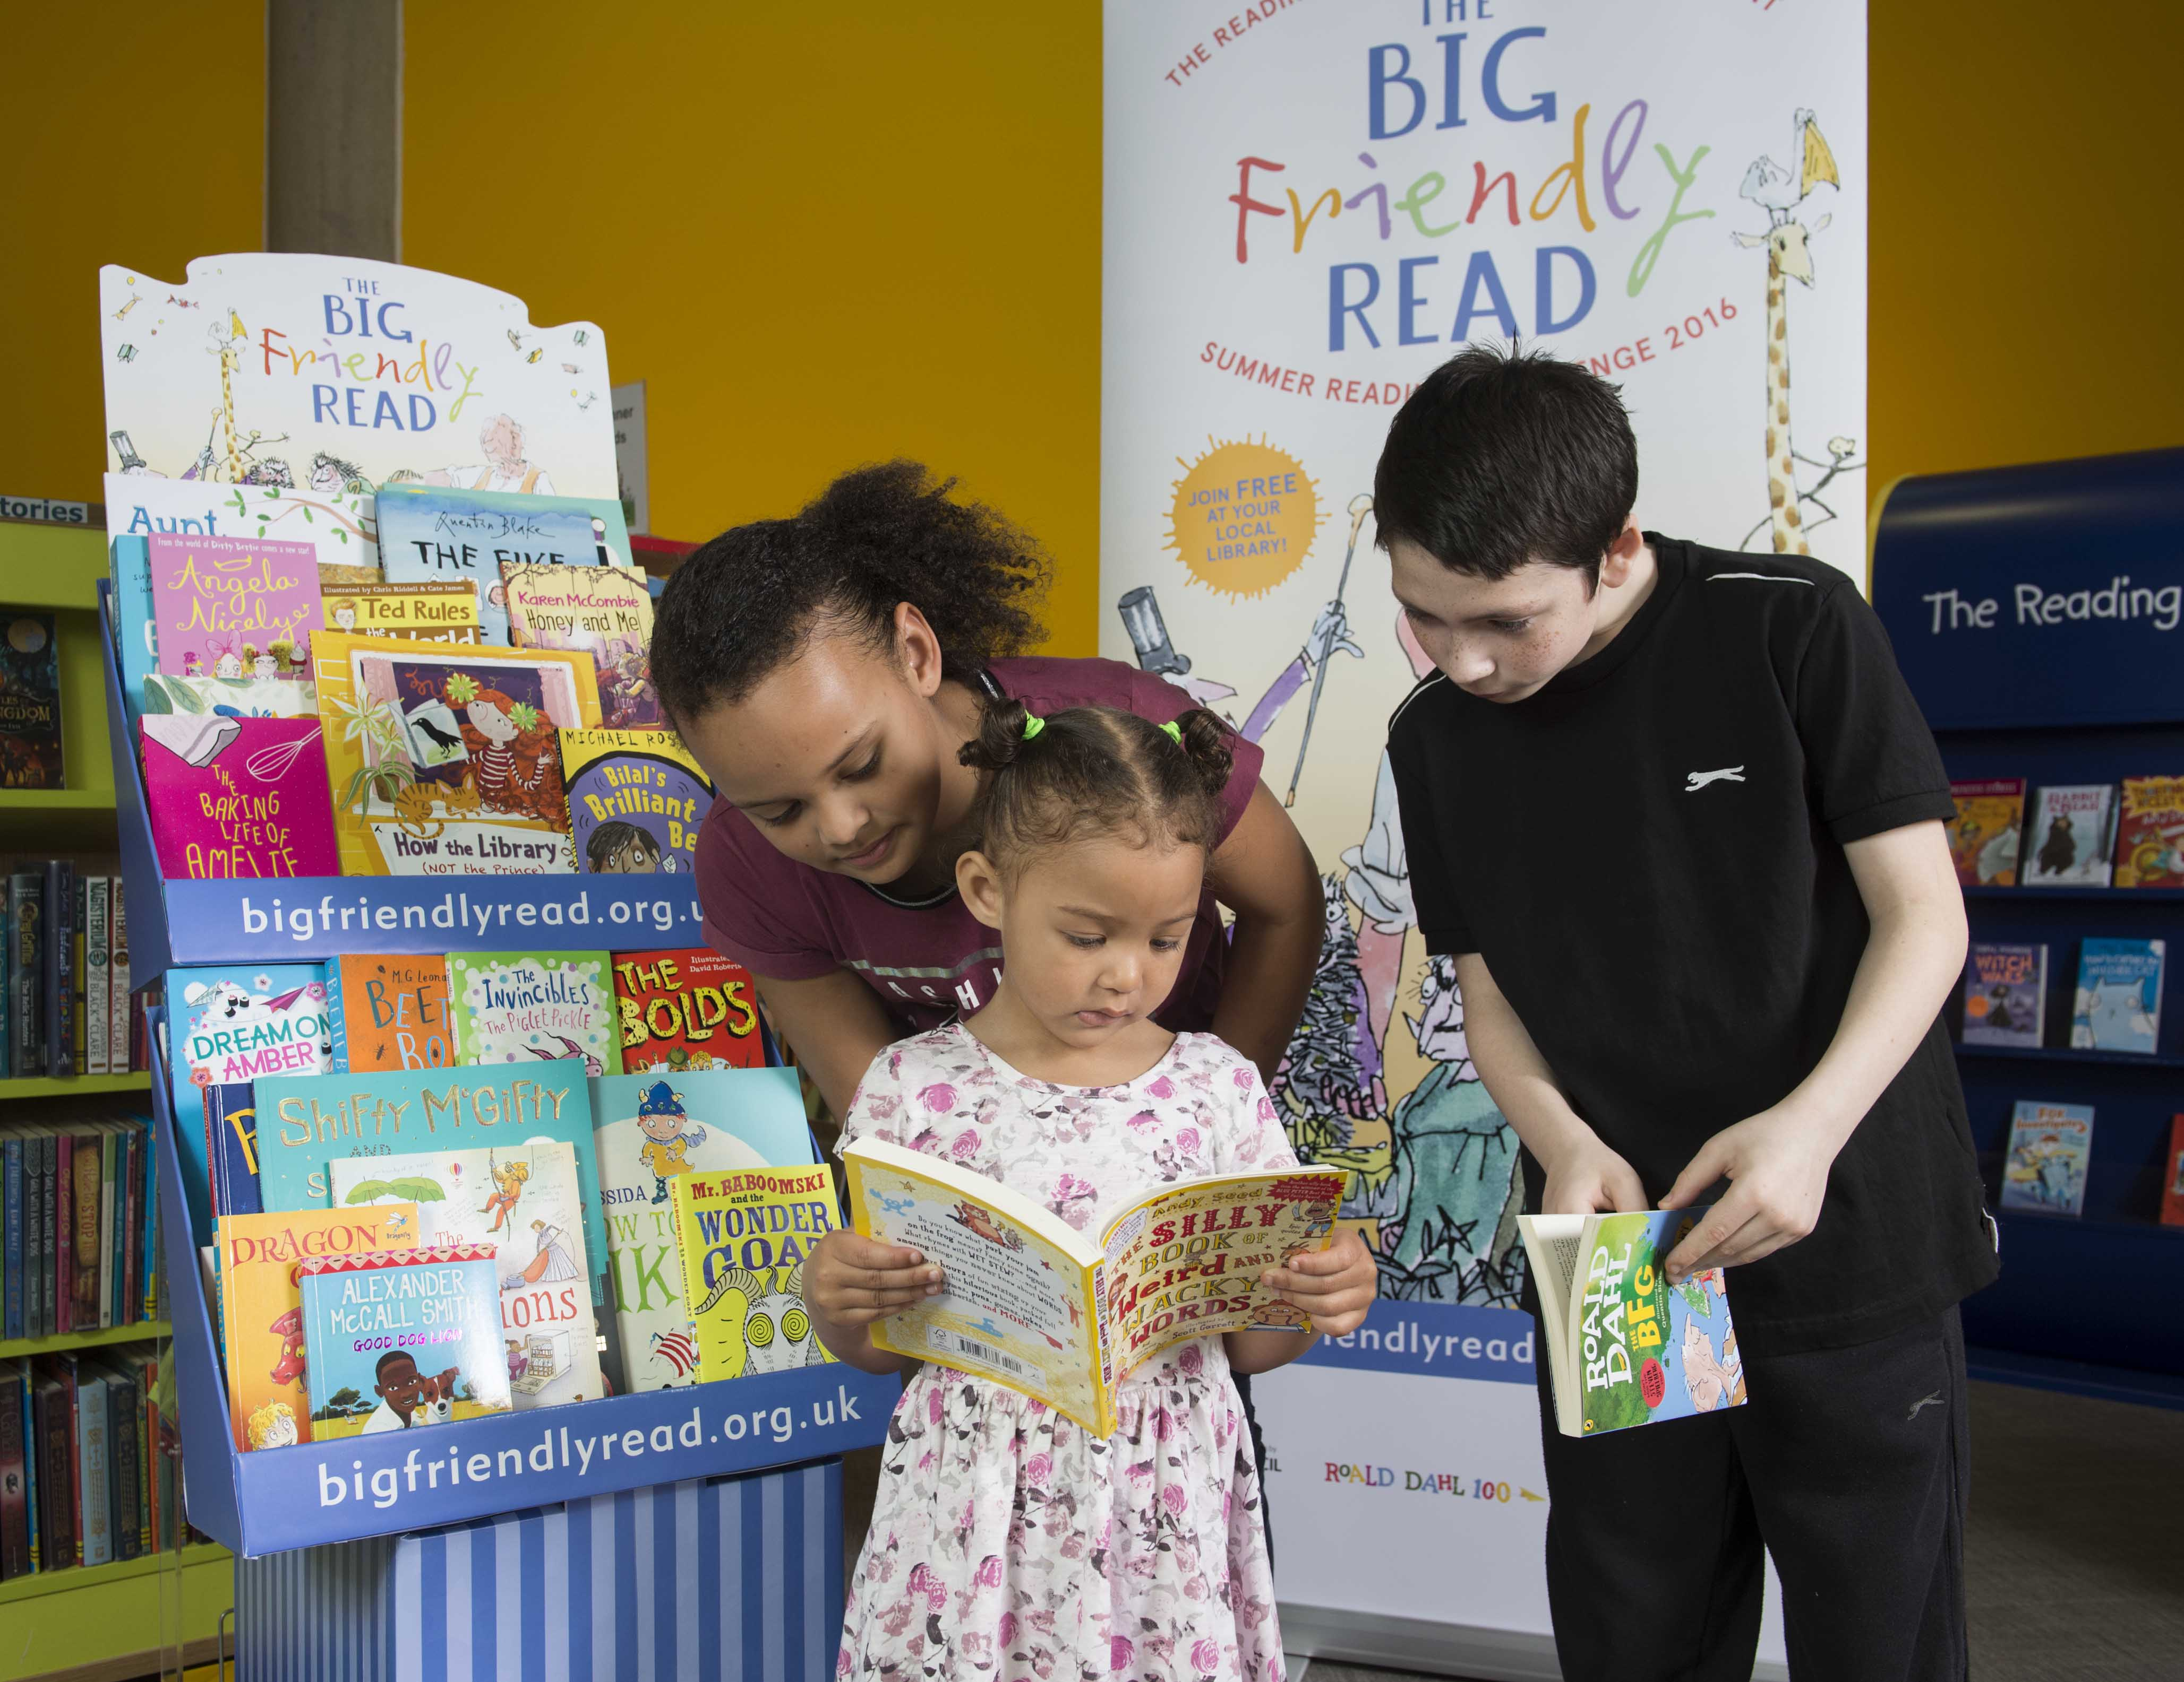
When I have finished my book I can tell the library staff about it.  They will give me a card to keep in my folder. | 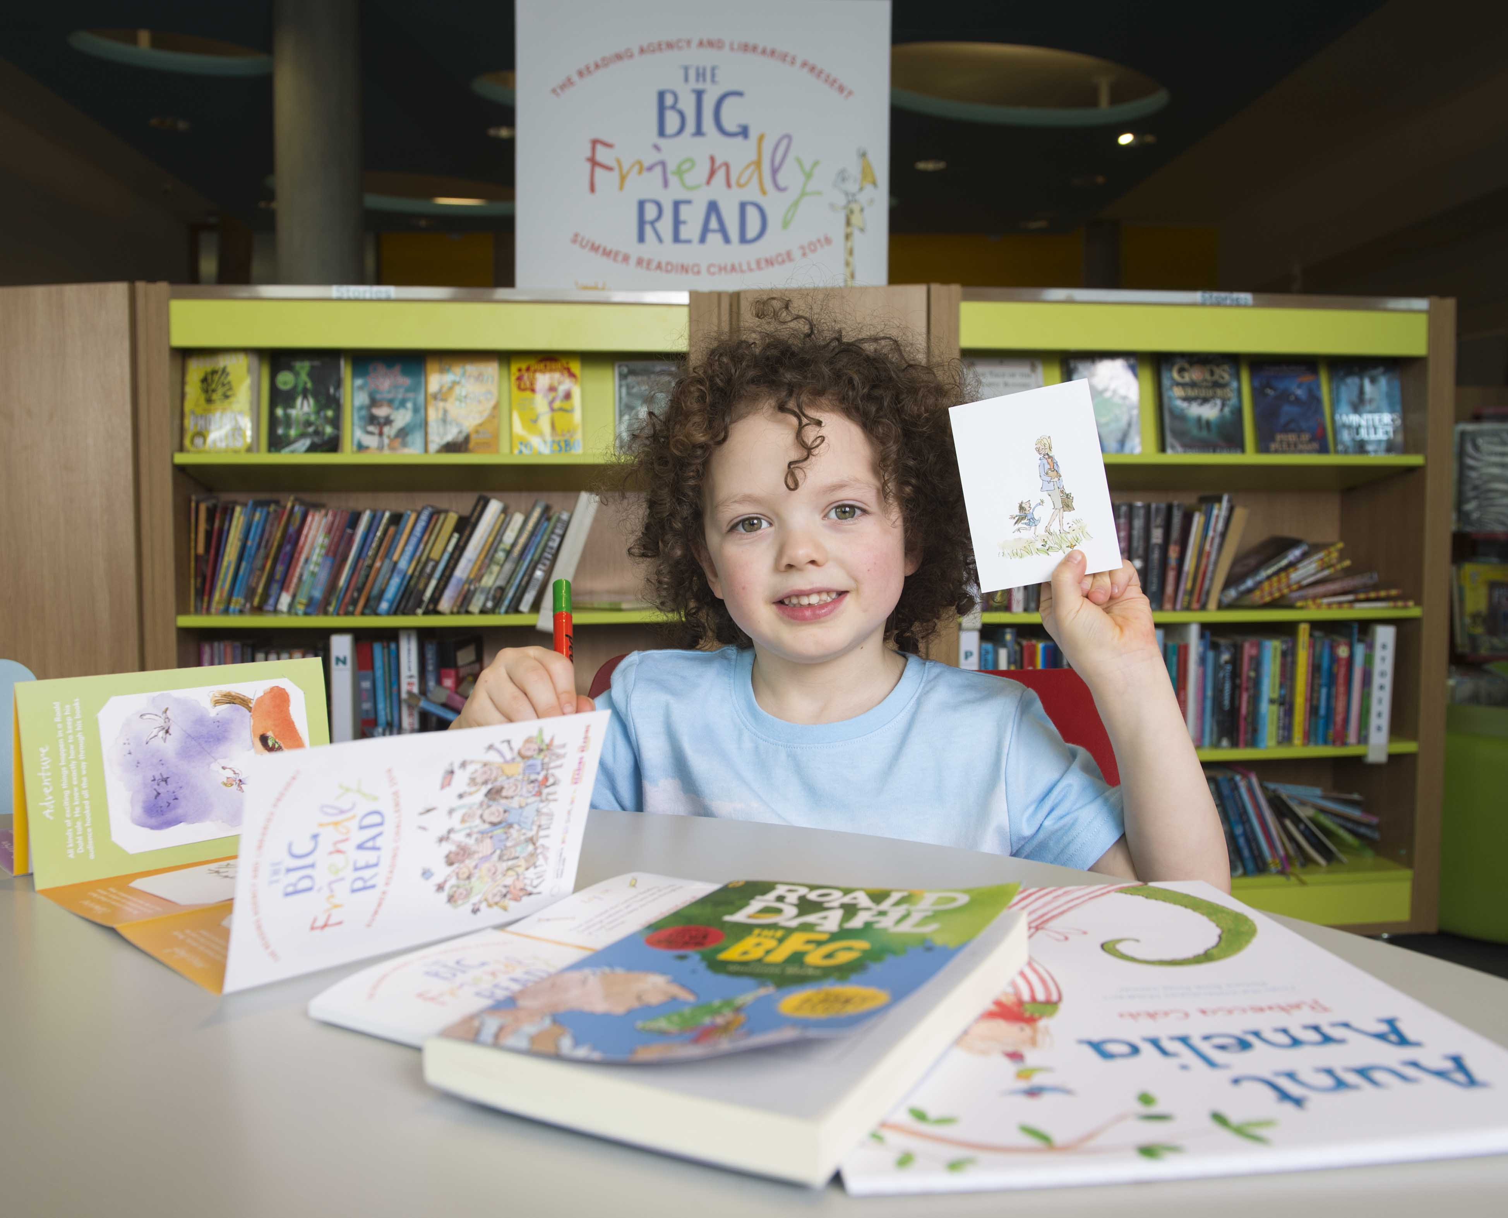

When I have completed the challenge

When I have finished my 6 books I will go the library and tell them.

The library staff will give me a certificate with my name on and a medal. | 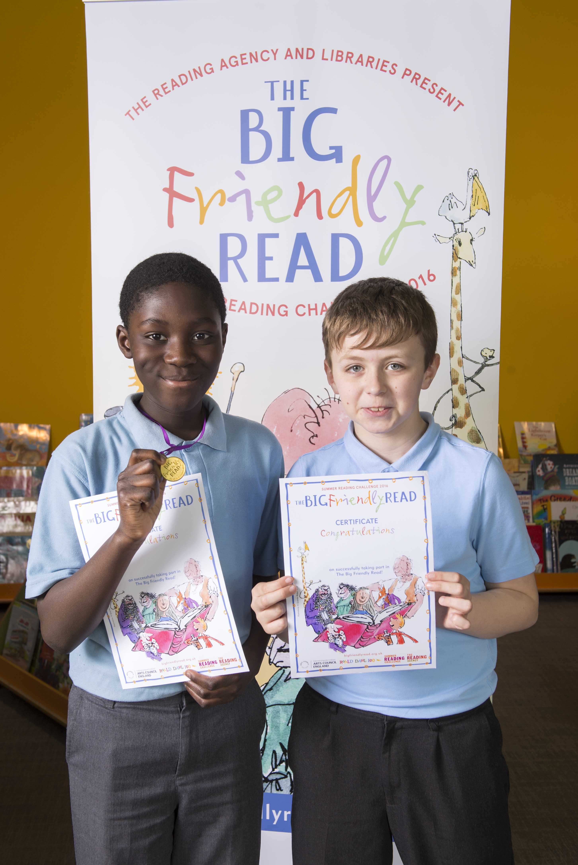
When I have finished I will leave the library

